=========
理论基础：
=========

========================================================

LLG:
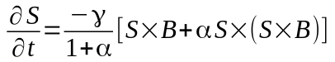
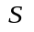: 原子磁矩的归一化矢量
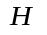:有效磁场，按我们的习惯，应该写成B，已经改了
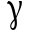: 旋磁比（常数=1.76e11）
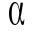:阻尼系统
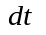:积分步长（在原子级别，为保证积分的稳定性，通常设置为0.5e-15 s,即0.5fs)

磁矩在场中的能量表达式：
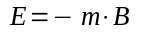 所以有效场的表达式为：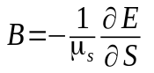

vampire作者在论文中也提到，作者认为有效场的单位是Tesla，所以公式中也应该写为B，这样更合理！

从下图可以看出，作者applied field H的单位写的是T（Tesla),而通常我们习惯于H的单位是A/m,
所以作者的公式实际上应该写成B (当然这是相对于我们的习惯)。

where μ s is the local spin moment. The inclusion of the spin

moment within the effective field is significant, in that the

field is then expressed in units of Tesla

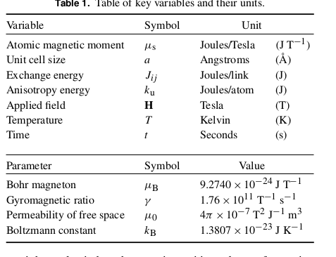

=======================================================================

1: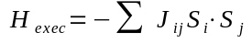
当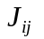是正数时，相邻自旋磁矩平行时，exchange interaction energy最小，所以这种材料是铁磁性材料，反之为负数时，exchange interaction energy最小，这种材料是反铁磁性coupling

2: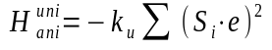
这里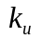的值只能为正数，当后面的平方为和为1时，单轴各向异性能最小

3: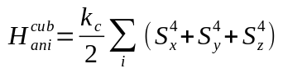
这里的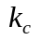只能为负数，这样才能让三轴各向异性能最小，

4: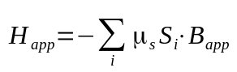
当磁矩与外加场平行时,能量最小

Hamilton量为能量总和：
, 各种其它导入方式

从Hamilton能量式得到总的场的公式：

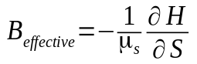, 有效场的单位为Tesla

=======================================================================

关键问题：
1:原子磁矩有效场的表达分类和计算
2:LLG的数值计算方法
3:材料的形状问题
Vampire的大框架

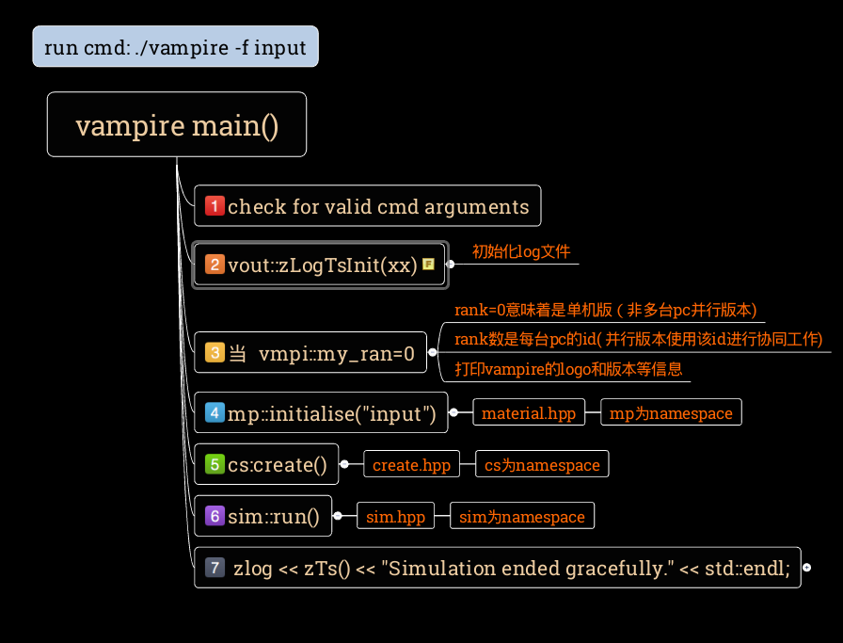

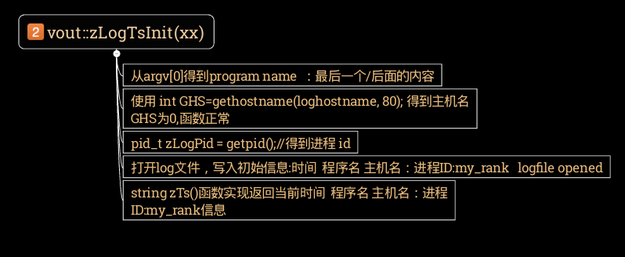

第一个重要函数：初始化函数

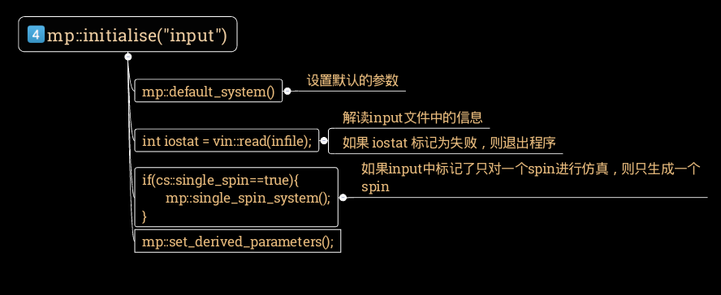

mp::default_system()中需要设置的参数
sim::UniaxialKu=1 | 单轴各向异性有关
cs::system_creation_flags[i]=0 (i=0,9) | 与材料创建时有关
sim::hamiltonian_simulation_flags[i] = 0 (i=0,9) | 与哈密顿量的分量是否有效有关
cs::unit_cell_size[i]=3.0 (i=0,1,2 x,y,z) | 原包的大小
cs::system_dimensions[i] = 100.0; (i=0,1,2 x,y,z) | 材料的大小
cs::particle_scale =50 | 不知
cs::particle_spacing = 10.0 | 微粒之间的间隙
cs::particle_creation_parity=0 | 不知
cs::crystal_structure ="sc" | 晶体的结构
create_voronoi::voronoi_sd=0.1 | 与voronoid有关
create_voronoi::parity=0 | 与voronoid有关
sim::hamiltonian_simulation_flags[0] = 1; | Exchange interaction
sim::hamiltonian_simulation_flags[1] = 1; | Anisotropy
sim::hamiltonian_simulation_flags[2] = 1; | Applied
sim::hamiltonian_simulation_flags[3] = 1; | Thermal
sim::hamiltonian_simulation_flags[4] = 0; | Dipolar
dt_SI = 1.0e-15; | 数值积分步长 1fs (ms,us,ns,ps,fs)
dt = dt_SI*mp::gamma_SI; | gamma_SI = 1.76E11;  电子的旋磁比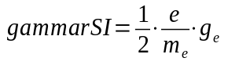
half_dt = 0.5*dt;
num_materials=1; | 材料的种类（实为原子的种类）
material.resize(num_materials); | material数据类型中包含丰富的信息
material[0].name="Co";  material[0].alpha=0.1;  material[0].Jij_matrix_SI[0]=-11.2e-21;  material[0].mu_s_SI=1.5*9.27400915e-24;  material[0].Ku1_SI=-4.644e-24;  material[0].gamma_rel=1.0;  material[0].element="Ag "; | 材料需要的默认参数：name 和 element有重叠，alpha为damping const, Jij是自身spin与spin的交换相互作用常数，mu_s_SI为SI单位的spin moment大小（9.274e-24为玻尔磁子大小)，  Ku1_SI是单轴各向异性常数，  gamma_rel为相对旋磁比
err::check=false; | 打开后，在进入每个函数时，都会打印进入当前函数信息
mtrandom::grnd.seed(2106975519); | 初始化随机数生成器

Material.hpp 文件中100行class materials_t;融入了作者对物理材料的理解，每个参数都有其对应的物理意义

思考：在写程序时，做一个log日志写入的文件还是非常不错的，程序中止时，也可以知道在哪个函数出了问题，方便自己调试
======================================================================
int read(const string filename)函数：

1：打印信息到log文件
2：打开input文件，并确保打开文件成功
3：打印”Parsing system parameters from main input files”到log文件
4：逐行读取input文件中内容，解析行内容，key word value unit line_counter
int matchcheck = match(key, word, value, unit, line_counter);
根据key值不同，调用不同的match函数
vin::match_create(word, value, unit, line);
vin::match_dimension(word, value, unit, line);
vin::match_sim(word, value, unit, line);
vin::match_vout_list(word, value, line, vout::file_output_list);
vin::match_vout_list(word, value, line, vout::screen_output_list);
vin::match_vout_grain_list(word, value, line, vout::grain_output_list);
vin::match_config(word, value, line);
ltmp::match_input_parameter(key, word, value, unit, line)
read_mat_file(matfile,line);
cs::unit_cell_file=matfile;
5：关闭input文件

match(key,word,value,unit,line_counter)中可匹配的参数
vio.cpp 753 与input文件和materila,ucf文件匹配
key | word | value | unit
create | full
create | cube
create | cylinder
create | ellipsoid
create | sphere
create | truncated-octahedron
create | tear-drop
create | particle
create | particle-array
create | hexagonal-particle-array
create | voronoi-film
create | voronoi-size-variance | float
create | voronoi-row-offset
create | voronoi-random-seed | int
create | voronoi-rounded-grains
create | voronoi-rounded-grains-area | double
create | particle-centre-offset
create | crystral-structure | string
create | single-spin
create | periodic-boundaries-x
create | periodic-boundaries-y
create | periodic-boundaries-z
create | select-material-by-height | bool
create | select-material-by-geometry | bool
create | fill-core-shell-particles | bool
create | interfacial-roughness | bool
create | material-interfacial-roughness | bool
create | interfacial-roughness-random-seed | uint
create | interfacial-roughness-number-of-seed-points | int
create | interfacial-roughness-type | string(peaks,troughs,空)
create | interfacial-roughness-seed-radius | double
create | interfacial-roughness-seed-radius-variance | double
create | interfacial-roughness-mean-height | double
create | interfacial-roughness-maximum-height | double
create | interfacial-roughness-height-field-resolution | double
create | multilayers | int
create | height-categorization | string(default,multilayers)
dimensions | unit-cell-size | double
dimensions | unit-cell-size-x | double
dimensions | unit-cell-size-y | double
dimensions | unit-cell-size-z | double
dimensions | system-size | double
dimensions | system-size-x | double
dimensions | system-size-y | double
dimensions | system-size-z | double
dimensions | particle-size | double
dimensions | particle-spacing | double
dimensions | particle-shape-factor-x | double
dimensions | particle-shape-factor-y | double
dimensions | particle-shape-factor-z | double
dimensions | particle-array-offset-x | double
dimensions | particle-array-offset-y | double
dimensions | macro-cell-size | double
sim | integrator | llg-heun (0)
sim | integrator | monte-carlo(1)
sim | integrator | llg-midpoint(2)
sim | integrator | constrained-monte-carlo(3)
sim | integrator | Hybrid-constrained-monte-carlo(4)
sim | program | benchmark(0)
sim | program | time-series(1)
sim | program | hystersis-loop(2)
sim | program | static-hysteresis-loop(3)
sim | program | curie-temperature(4)
sim | program | field-cool(5)
sim | program | laser-pulse(6)
sim | program | hamr-simulation(7)
sim | program | cmc-anisotropy(8)
sim | program | hybrid-cmc(9)
sim | program | reverse-hybrid-cmc(10)
sim | program | LaGrange-Multiplier(11)
sim | program | partial-hysteresis-loop(12)
sim | program | localised-temperature-pulse(13)
sim | program | effective-damping(14)
sim | program | diagnostic-boltzmann(50)
sim | enable-dipole-fields | 哈密顿分量置1
sim | enable-fmr-field | 哈密顿分量置1
sim | enable-fast-dipole-fields | （结果demag::fast=true;）
sim | dipole-field-update-rate | int
sim | enable-surface-anisotropy
sim | surface-anisotropy-threshold | string(native) or int
sim | surface-anisotropy-nearest-neighbour-range | double(表示distance)
sim | time-step | Double (各分步长)
sim | total-time-steps | int
sim | loop-time-steps | int
sim | partial-time-steps | int
sim | time-steps-increment | int
sim | equilibration-time-steps | int
sim | simulation-cycles | int
sim | maximum-temperature | double
sim | minimum-temperature | double
sim | equilibration-temperature | double
sim | temperature | double
sim | temperature-increment | double
sim | cooling-time | double
sim | laser-pulse-temporal-profile (后面的参数主要用来设置sim::pump_function的值) | square
sim |  | two-temperature
sim |  | double-pulse-two-temperature
sim |  | double-pulse-square
sim | laser-pulse-time | double
sim | laser-pulse-power | double
sim | second-laser-pulse-time | double
sim | second-laser-pulse-power | double
sim | second-laser-pulse-maximum-temperature | double
sim | second-laser-pulse-delay-time | double
sim | two-temperature-heat-sink-coupling | double
sim | two-temperature-electron-heat-capacity | double
sim | two-temperature-phonon-heat-capacity | double
sim | two-temperature-electron-phonon-coupling | double
sim | cooling-function  (设置sim::cooloing_funciton=0,1,2,3) | exponential
sim | cooling-function  (设置sim::cooloing_funciton=0,1,2,3) | gaussian
sim | cooling-function  (设置sim::cooloing_funciton=0,1,2,3) | double-gaussian
sim | cooling-function  (设置sim::cooloing_funciton=0,1,2,3) | linear
sim | applied-field-strength | double
sim | minimum-applied-field-strength | double
sim | maximum-applied-field-strength | double
sim | equilibration-applied-field-strength | double
sim | applied-field-strength-increment | double
sim | applied-field-angle-theta | double
sim | applied-field-angle-phi | double
sim | applied-field-unit-vector | vector<double>
sim | demagnetisation-factor | Vector<double>
sim | mpi-mode | geometric-decomposition
sim | mpi-mode | replicated-data
sim | mpi-mode | eplicated-data-staged
sim | mpi-ppn | int
sim | integrator-random-seed | int
sim | integrator-random-seed | int
sim | constraint-angle-theta | int
sim | constraint-angle-theta-minimum | double
sim | constraint-angle-theta-maximum | double
sim | constraint-angle-theta-increment | double
sim | constraint-angle-phi | double
sim | constraint-angle-phi-minimum | double
sim | constraint-angle-phi-maximum | double
sim | constraint-angle-phi-increment | double
sim | Monte-carlo-algorithm  (set sim::mc_algorithm) | spin-flip
sim | Monte-carlo-algorithm  (set sim::mc_algorithm) | uniform
sim | Monte-carlo-algorithm  (set sim::mc_algorithm) | angle
sim | Monte-carlo-algorithm  (set sim::mc_algorithm) | hinzke-nowak
sim | save-checkpoint | end
sim | save-checkpoint | continuous
sim | save-checkpoint-rate | int
sim | load-checkpoint | restart
sim | load-checkpoint | continue
screen和ouput调用共同的match函数  三个变量分别保存着哪些信息需要输出：  vout::file_output_list  vout::screen_output_list  vout::grain_output_list | time-steps | output_list.push_back(0);
 | real-time | output_list.push_back(1);
 | temperature | output_list.push_back(2);
 | applied-field-strength | output_list.push_back(3);
 | applied-field-unit-vector | output_list.push_back(4);
 | applied-field-alignment | output_list.push_back(12);
 | magnetisation | output_list.push_back(5);
 | magnetisation-length | output_list.push_back(6);
 | mean-magnetisation-length | output_list.push_back(7);
 | material-magnetisation | output_list.push_back(8);
 | material-mean-magnetisation-length | output_list.push_back(9);
 | total-torque | output_list.push_back(14);
 | total-torque | output_list.push_back(15);
 | constraint-phi | output_list.push_back(16);
 | constraint-theta | output_list.push_back(17);
 | material-constraint-phi | output_list.push_back(18);
 | material-constraint-theta | output_list.push_back(19);
 | material-mean-torque | output_list.push_back(20);
 | mean-susceptibility | output_list.push_back(21);
 | electron-temperature | output_list.push_back(2);
 | phonon-temperature | output_list.push_back(22);
 | material-temperature | output_list.push_back(23);
 | material-applied-field-strength | output_list.push_back(24);
 | material-fmr-field-strength | output_list.push_back(25);
 | material-applied-field-alignment | output_list.push_back(26);
 | total-energy | output_list.push_back(27);
 | mean-total-energy | output_list.push_back(28);
 | anisotropy-energy | output_list.push_back(29);
 | mean-anisotropy-energy | output_list.push_back(30);
 | cubic-anisotropy-energy | output_list.push_back(31);
 | mean-cubic-anisotropy-energy | output_list.push_back(32);
 | surface-anisotropy-energy | output_list.push_back(33);
 | mean-surface-anisotropy-energy | output_list.push_back(34);
 | exchange-energy | output_list.push_back(35);
 | mean-exchange-energy | output_list.push_back(36);
 | applied-field-energy | output_list.push_back(37);
 | mean-applied-field-energy | output_list.push_back(38);
 | magnetostatic-energy | output_list.push_back(39);
 | mean-magnetostatic-energy | output_list.push_back(40);
 | second-order-uniaxial-anisotropy-energy | output_list.push_back(41);
 | mean-second-order-uniaxial-anisotropy-energy | output_list.push_back(42);
 | height-magnetisation-normalised | output_list.push_back(43);
 | material-height-magnetisation-normalised | output_list.push_back(44);
 | height-magnetisation | output_list.push_back(45);
 | material-height-magnetisation | output_list.push_back(46);
 | mpi-timings | output_list.push_back(60);
 | Ku | output_list.push_back(61);
 | gnuplot-array-format
 | output-rate | int
grain | time-steps | output_list.push_back(0);
grain | real-time | output_list.push_back(1);
grain | temperature | output_list.push_back(2);
grain | applied-field-strength | output_list.push_back(3);
grain | applied-field-unit-vector | output_list.push_back(4);
grain | magnetisation | output_list.push_back(10);
grain | mag-m | output_list.push_back(11);
grain | material-magnetisation | output_list.push_back(13);
grain | electron-temperature | output_list.push_back(2);
grain | phonon-temperature | output_list.push_back(22);
grain | output-rate | int
config | atoms
config | atoms-output-rate | int
config | atoms-minimum-x | double
config | atoms-minimum-y | double
config | atoms-minimum-z | double
config | atoms-maximum-x | double
config | atoms-maximum-y | double
config | atoms-maximum-z | double
config | macro-cells
config | macro-cells-output-rate | int
config | identify-surface-atoms
material | file | string(材料文件名)  read_mat_file(matfile,line)
material | unit-cell-file | string(unit-cell方件名)  cs::unit_cell_file=matfile;

=======================================================================
==========================================
vout::zLogTsInit(std::string(argv[0]))：
==========================================
1：从argv[0]得到program name ：最后一个/后面的内容

2：使用 int GHS=gethostname(loghostname, 80); 得到主机名
GHS为0,函数正常

3：pid_t zLogPid = getpid();//得到进程 id
===========================================

4：如果为单机版 ，log文件名为”log”,多pc并行版本,log文件为”log.n” (n为每台机器上的my_rank号

std::stringstream logfn;
if(vmpi::num_processors==1)
logfn << "log";
else
logfn << "log."<<vmpi::my_rank;

std::string log_file = logfn.str(); // stringstream 类型转化为 string类型
const char* log_filec = log_file.c_str(); //string类型到char *类型

std::ofstream zlog;
zlog.open(log_filec);
zLogInitialised=true; //log文件已经初始化标志 (表明zLog变量已经初使化完成，可以向zlog文件中写入信息了)
向文件中写信息：
zlog<<zTs()<<”logfile opened”<<std::endl;

zTs()函数返回 字符串string:
会判断 zLogInitialised 变量是否为true，只有zlog变量被初始化了，才能向zlog<<写入数据
时间 程序名 [主机名：进程名：my_rank]
2016-03-24 15:17:48 vampire [ubuntu-ht:11473:0]

=======================================================================

==========================================
std::string zTs()
==========================================
std::ostringstream Ts;
time_t seconds;
// get current time
seconds = time (NULL);
struct tm * timeinfo;
char logtime [80];
timeinfo = localtime ( &seconds );
// Format time string
strftime (logtime,80,"%Y-%m-%d %X ",timeinfo);
Ts << logtime ;
cout<<Ts.str();
=======================================================================

==========================================
mp::initialise(infile);
==========================================

mp::default_system();
int iostat=vin::read(input);
if(iostat==EXIT_FAILURE) exit(1); //程序读取input文件内容解析失败
//方便调试打印信息
for (int i=0;i<mp::num_materials;i++)
mp::material[i].print();
//
if(cs::single_spin==true){ //如果input文件中指定了只生成一个spin
mp::single_spin_system();
}
mp::set_derived_parameters(); //基于刚才从input读取出来的信息，设置需要计算的变量

